Problem Set 4

Due on Gradescope: check the course Drive calendar
Consult the Late Policy in the syllabus

Instructions: Work with this file as a template, perhaps by File: Download: Microsoft Word. Other options, like handwriting, are fine as long as they are legible. Name and SID at the top.

Did you work with other students? Identify them below. If you work with others, you should write answers in your own words. (If you understand your answers, this should be easy.)

Type your name to sign the Honor Code. Save as a PDF, upload to Gradescope, and click through to locate each question part before clicking Submit. Profit.

You will see point totals associated with each question. But we will score your problem sets based on completion, not correctness. The point totals are there to make you familiar with how the exams will work, which are scored on correctness.

Questions below:
1. [20 points total] Short answer questions
2. [20 points total] Saved by how the Government always asks about Investment
3. [40 points total] The Financial Crisis and the Short-Run Model

Did you work with other students? List them below:

Please type your name as an affirmation of the Honor Code at the University of California, Berkeley.

“As a member of the UC Berkeley community, I act with honesty, integrity, and respect for others.”

Type your name:

1. [20 points total] Short answer questions

- [2 points] Suppose that a nation engages in what becomes a protracted war overseas. But no military reservists are called up and away from their civilian jobs. What is the most obvious eﬀect on that nation’s GDP and why? (There’s no need to get fancy with your answer.)

- [3 points] What, if anything, is the danger posed by financing the war through government budget deficits? Explain. (There are multiple correct answers; just explain one.)

Recall that almost all loans are written as nominal contracts, meaning that borrowers agree to pay lenders a specific amount or amounts of money in the future in exchange for a specific amount of money today. The nominal interest rate is the annualized rate of return implicit in the nominal contract.

- [3 points] Can the real interest rate ever be negative? If yes, under what circumstances? If no, why not?

- [(3 points) Suppose inflation were to rise unexpectedly. In credit markets — think of banks and their customers — whom would this hurt, if anyone? Whom would this help, if anyone? Explain.

Politicians who like low inflation ($π$) typically also like a “strong dollar,” meaning that the dollar’s nominal exchange rate (E) is high, for example when the dollar ($) purchases many yen (¥) or euros (€).

- [4 points] State whether these two views are consistent or inconsistent with one another, and explain why. (There is a single correct answer, meaning either one or the other, but I think you could defend it at least two diﬀerent ways. State at least one explanation.)

- [3 points] From the following list of constituencies (meaning political groups represented in the nation and in government), identify those that the “strong dollar” politicians probably represent, and briefly explain why.

- Exporters
- Consumers of imports
- Savers
- Borrowers
- Workers
- Retirees

2. [20 points total] Saved by how the Government always asks about Investment

Recall that national income accounting requires that

Y = C + I + G + EX – IM (2.1)

Total spending — consumption, investment, government, and net exports — sums to GDP, or national production, which is also equal to national income. Throughout this problem, it will help you to think of Y as income and fixed in the short run, even though in reality it is not.

- [3 points] Leave EX – IM on the right-hand side and subtract everything else except Y from both sides.

- [3 points] On the left-hand side, add and subtract taxes, T. By bracketing with parentheses and labeling, show: (i) private saving, (ii) public or government saving, and (iii) investment.

Recall that in ECON 100B, we typically assume that total taxes T and income tax rates do not change working or consuming behavior. In other words, increases in taxes T directly reduces after-tax income, but we assume that higher tax rates do not change labor supply or income, and that they also do not change consumption. (For small changes, this is probably realistic.)

- [3 points] Under these assumptions, what are the eﬀects, if any, of an increase in taxes, T, according to your answer to part (b)? What about a reduction in taxes? Explain.

- [3 points] Make an argument for why the government should run a budget surplus by reducing G below T. Describe how that might increase a component of GDP, using equation (2.1) and your answer to part (b). (I can think of two; choose one.)

- [3 points] Now make a macroeconomic argument for why the government should run a budget deficit, by raising G above T. Describe how that could be good for GDP, using equation (2.1) and your answer to part (b) as need be.

Suppose I told you that research in macroeconomics suggests that when the government spends an additional ∆G = $1.00 on national defense, it appears that GDP actually rises on net by about ∆Y = $0.80 as a result. Why? Government spending partially crowds out other components of GDP, because it requires either higher taxes or higher borrowing or both.

- [5 points] Discuss this in light of your previous answers. Does this perspective suggest that one of the two arguments in parts (d) and (e) might be more wise? Explain fully.

3. [40 points total] The Financial Crisis and the Short-Run Model

In the second half of ECON 100B, we learn about the roles played by fiscal and monetary policy in promoting short-term macroeconomic stability, and we briefly discuss banks. How can we use the short-run model to understand the Financial Crisis of 2008 and the policy response?

Recall the standard IS, MP, and PC Curves we saw in class:
IS curve $\tilde{Y}=\bar{a}+\bar{b}(R-\bar{r})$ (3.1)
MP curve $R=R^{ff}+\bar{p}$ (3.2)
PC curve $Δπ=\bar{v} \tilde{Y}+\bar{o}$ (3.3)
where R is the real interest rate paid by borrowers; $\bar{r}$ is the marginal product of capital; $R^{ff}$ is the real federal funds rate, set by the U.S. central bank, the Federal Reserve (“Fed”); $\bar{p}$ is the risk premium charged by private lenders and paid by borrowers; $π$ is the inflation rate; $\bar{o}$ is an oil shock or other external inflation shock that can temporarily shift the Phillips Curve; and $\bar{a}$, $\bar{b}$, and $\bar{v}$ are all positive parameters.

- [4 points] Draw and label the IS-MP and PC Curves on the axes below.
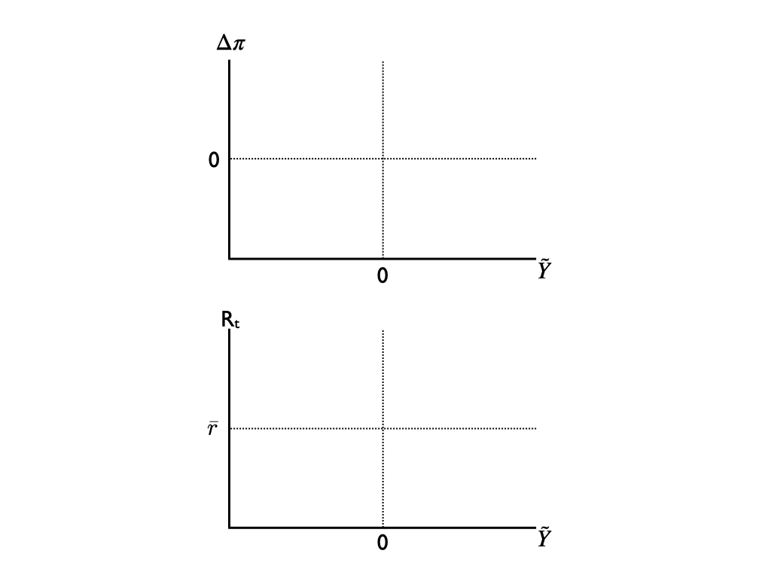
- [3 points] Look at equations (3.1), (3.2), and (3.3) and report which TWO elements in the short-run model dictate the eﬀectiveness of monetary policy in the short-run model. In other words: Suppose the Fed sees a big negative shock and lowers $R^{ff}$ by three percentage points, but there are two elements that determine the response of short-run output, $\tilde{Y}$. What are they? (Recall that the Fed cannot formally dictate borrowing terms in private markets.)

Consider the behavior of consumers before and after the crisis. Suppose that in normal times, consumers spend a portion $mpc$ of their excess current income in addition to the constant share ${\bar{a}}_{c}$ of their permanent income. Then the components of GDP behave like this:
Consumption $C/\bar{Y}={\bar{a}}_{c}+mpc ×\tilde{Y}$ (3.4)
Investment $I/\bar{Y}={\bar{a}}_{i}-\bar{b}(R-\bar{r})$ (3.5)
Government $G/\bar{Y}={\bar{a}}_{g}$ (3.6)
Net exports $NX/\bar{Y}={\bar{a}}_{nx}$ (3.7)
The next 5 questions step you through the process of deriving the IS curve under these conditions. Question (g) is the finish line, and you can jump to the end if you want, but for full credit, please show your work.

- [2 points] Write down the national income identity relating income Y to consumption and other elements of activity.

- [2 points] Divide both sides of your answer to part (c) by $\bar{Y}$.

- 2 points] Substitute equations (3.4)-(3.7) into your answer to part (d).

- [2 points] Take your answer to part (e) and subtract 1 from both sides. On the left side, simplify. On the right side, define the sum of the $\bar{a}$’s and the 1 as a new $\bar{a}$ term, and rewrite in terms of $\bar{a}$, $mpc$, $\tilde{Y}$, and $\bar{b}(R-\bar{r})$.

- [2 points] Finally, combine terms containing $\tilde{Y}$ on one side and reveal the IS curve, showing $\tilde{Y}$ as a function only of R and parameters including $mpc$.

- [2 points) Has your answer to part (b) changed? Is there a third parameter that constrains the eﬀectiveness of monetary policy? If yes, what is it and why? If no, why not?

The following graph shows time series plots of real income (Y ) and real consumption (C) over time between January 2007 and April 2010. Income is the top line and consumption is the bottom line.
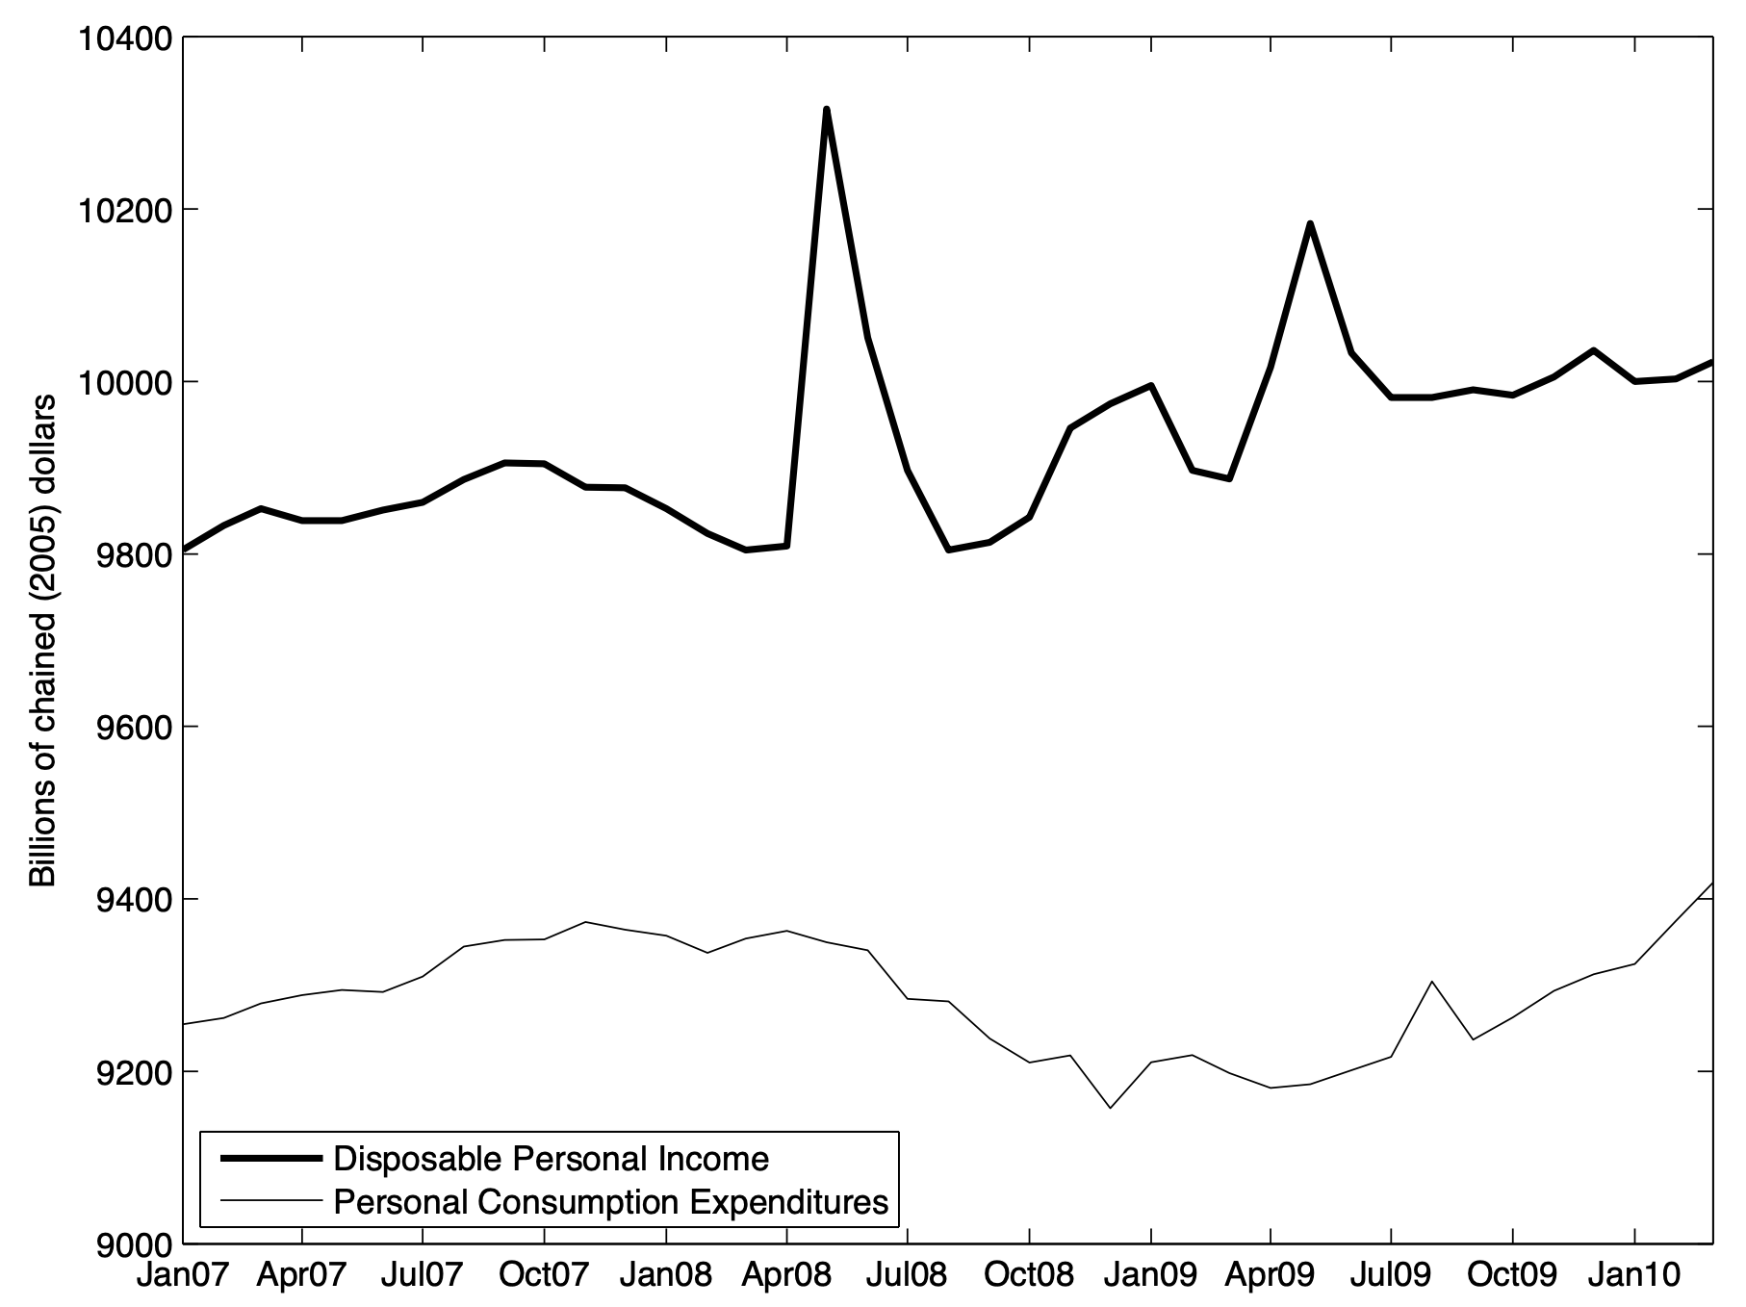

- [3 points] Normally, the “spender share” $mpc$, which is the proportion of temporary income fluctuations that are consumed, is probably around 30% or so. What seems to be true about the spender share here between January 2007 and January 2010? Give a rough estimate and explain.

- [3 points] Looking back at your answer to part (g), what, if anything, does your answer to part (i) imply about what has happened to the IS curve during the Financial Crisis? Explain. (Recall that in normal times, $mpc=0.3$ or so. Is that what you saw in part (i)?)

- 3 points] Changing gears: If some event prompts financial markets to perceive greater risk than they previously saw, what happens to $\bar{p}$ and thus R given any level of $R^{ff}$ ?

- [12 points] Use the axes below to produce a diagram showing the financial crisis, and in the space provided, narrate appropriately. Assume the financial crisis consists of these events, in order:
  - There is a massive fall in ${\bar{a}}_{c}=C/\bar{Y}$ as consumers reduce their spending share of potential GDP because they find their housing assets are worth far less than previously thought;
  - Consumers also change their behavior as you described in parts (i) and (j);
  - The Fed takes action to counteract these events; but
  - Financial markets behave as laid out in part (k)


Valerie A. Ramey (2011) “Identifying Government Spending Shocks: It’s All in the Timing,” Quarterly Journal of Economics 126(1): 1–50.

